EX. NO.: 21
TITLE
MYSQL STRING FUNCTIONS – SPACE, SUBSTR, UPPER, LOWER, TRIM, LENGTH
AIM
To implement SPACE, SUBSTR, UPPER, LOWER, TRIM, LENGTH string functions using MySQL.

PROCEDURE
- Select the MobileDB database.
- Use the SELECT statement to execute different MySQL string functions.
- Apply the functions to the MobileSales table where appropriate.
- Execute each command separately.
- Observe and verify the output.

COMMANDS
1. Select Database
USE MobileDB;
2. SPACE()
Returns a string containing the specified number of spaces.
SELECT MobileName, CONCAT(MobileName, SPACE(5), Price)
AS SpaceResult
FROM MobileSales;
3. SUBSTR()
SELECT MobileName, SUBSTR(MobileName, 1, 5)
AS SubstringValue
FROM MobileSales;

4. UPPER()
SELECT MobileName, UPPER(MobileName)
AS UpperName
FROM MobileSales;
5. LOWER()
SELECT MobileName, LOWER(MobileName)
AS LowerName
FROM MobileSales;
6. TRIM()
SELECT TRIM(' MobileSales ')
AS TrimResult;

7. RTRIM()
SELECT RTRIM('MobileSales ')
AS RightTrimResult;

8. LTRIM()
SELECT LTRIM(' MobileSales')
AS LeftTrimResult;

9. LENGTH()
SELECT MobileName, LENGTH(MobileName)
AS NameLength
FROM MobileSales;

10. BIT_LENGTH()
SELECT MobileName, BIT_LENGTH(MobileName)
AS BitLength
FROM MobileSales;

11. CHAR_LENGTH()
SELECT MobileName, CHAR_LENGTH(MobileName)
AS CharacterLength
FROM MobileSales;

12. CONCAT()
SELECT CONCAT(MobileName, ' - ', Price)
AS MobileDetails
FROM MobileSales;

13. INSTR()
SELECT MobileName, INSTR(MobileName, 'o')
AS PositionValue
FROM MobileSales;
14. LOCATE()
SELECT MobileName, LOCATE('o', MobileName)
AS PositionValue
FROM MobileSales;

15. MID()
SELECT MobileName, MID(MobileName, 1, 4)
AS MidValue
FROM MobileSales;

16. POSITION()
SELECT MobileName, POSITION('o' IN MobileName)
AS PositionValue
FROM MobileSales;
OUTPUTS
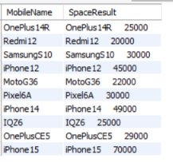
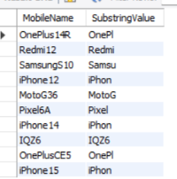

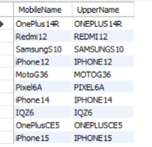
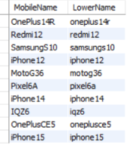
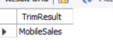
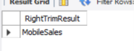
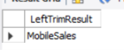
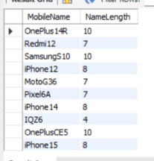
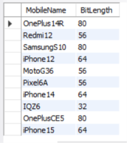
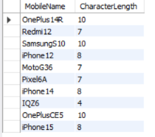
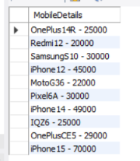
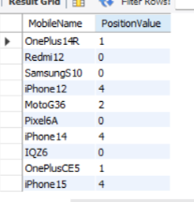
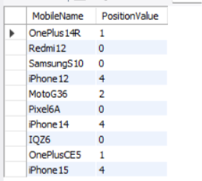
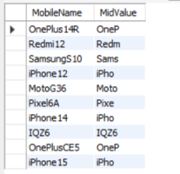

RESULT
Thus the MySQL string functions such as SPACE, SUBSTR, UPPER, LOWER, TRIM, LENGTH, RTRIM, LTRIM, BIT_LENGTH, CHAR_LENGTH, CONCAT, INSTR, LOCATE, MID and POSITION were executed successfully.

